SRS FOR ONLINE TELECOMMUNICATION SYSTEM

**Abstract**

The Software Requirement Specification (SRS) for the Telecom Application serves as a comprehensive document outlining the functional and non-functional requirements, system behaviour, and constraints of the proposed telecom application. This application aims to facilitate efficient communication services while ensuring reliability, scalability, and security in the telecommunications domain.

The SRS begins with an introduction providing an overview of the telecom application, its purpose, and scope. It delineates the stakeholders involved, including end-users, administrators, and developers, and highlights the significance of the application in enhancing communication infrastructure.

**Functional Requirements**

Functional requirements for an online Telecom define the specific features and functionalities that the system must provide to meet user and business needs. Here's a detailed breakdown of functional requirements for an online telecom system:

* Registration
* View plans
* Get new Connection
* Switch Service
* Order Management
* Make payment
* Customer Support

**Non Functional Requirement**

Non-functional requirements for an online Telecommunication system focus on qualities that are not directly related to specific functionalities but are critical for the overall success and effectiveness of the system. Here's a breakdown of non-functional requirements for an online Telecommunication system

* Performance
* Security
* Usability
* Scalability
* Reliability
* Scalability

**MODULES DESCRIPTION**

**1.Registration**

Users should be able to register with the platform by providing necessary details such as name, Mobile Number, and password. If customer wants to buy the plans or get New Connection then he/she must be registered, unregistered user can’t go to the buying plans. Implement mechanisms for password recovery and account activation.

**2.View Plans**

The View Plans module is an essential component of the telecommunication application, designed to enable users to explore and select suitable subscription plans offered by the service provider. This module serves as an interface between users and available service packages, providing comprehensive details and options for subscription management.

**3.Get New Connection**

The New Connection module is an integral component of the telecommunication application, designed to facilitate the process of acquiring new service subscriptions for users who are not yet registered with the telecom provider. This module serves as a user-friendly interface to guide individuals through the process of obtaining a new connection, whether it involves mobile, landline, or broadband services.

**4.Switch Service**

The Switch SIM Service module is a vital component of the telecommunication application, designed to enable existing users to switch their SIM cards to a new device or a different SIM card for various reasons such as device upgrade, loss of device, or change of SIM card type .This module ensures a smooth transition of service without disruption to the user's communication capabilities.

**5.Order Management**

Admins should have access to a dashboard to view and manage orders.

Users should receive email notifications for order confirmation, shipment, and delivery. Allow users to track the status of their orders in real-time. Automatically update plan details when orders are placed or cancelled.

**6.Make Payment**

The Bill Payment module is a crucial component of the telecommunication application, designed to facilitate the seamless and convenient payment of bills for subscribed services. This module provides users with various payment options and functionalities to manage their billing accounts, view invoices, and settle outstanding dues efficiently.

**7.Customer Support**

Email support with a dedicated email address and response timeframes Live chat functionality for real-time assistance, Phone support with clear operating hours and

FAQ section with answers to common customer questions.

**Flowchart**

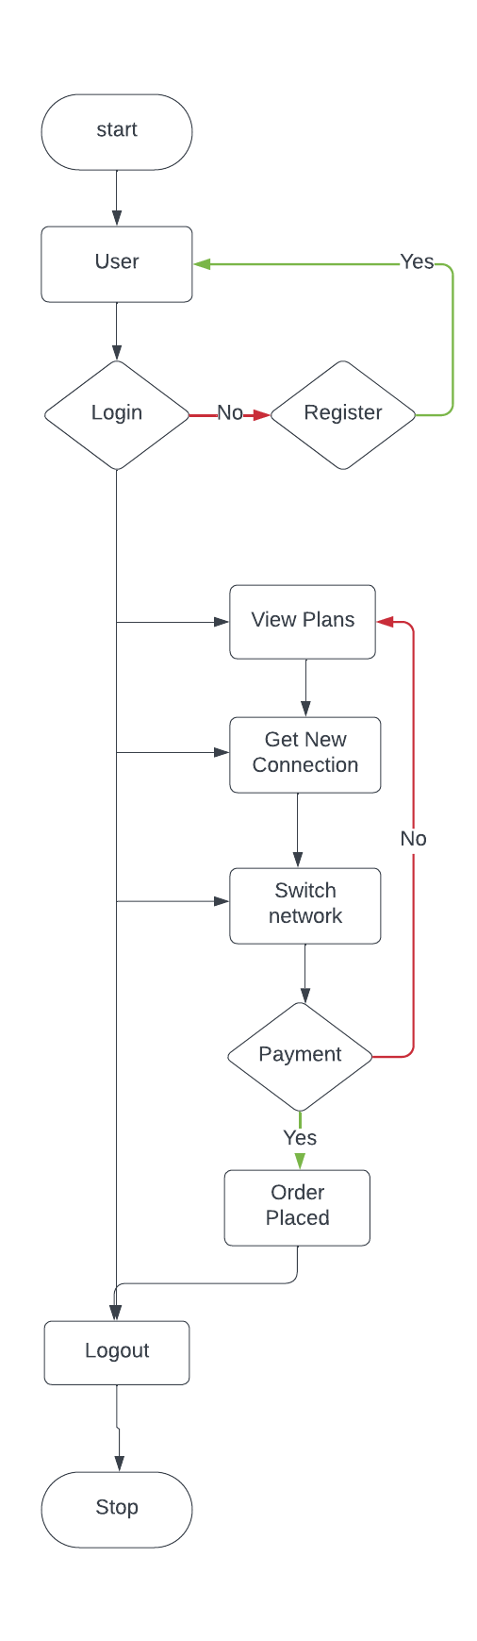

**Use case Diagram**

Use-case diagrams describe the high-level functions and scope of a system. These diagrams also identify the interactions between the system and its actors. The use cases and actors in use-case diagrams describe what the system does and how the actors use it, but not how the system operates internally.

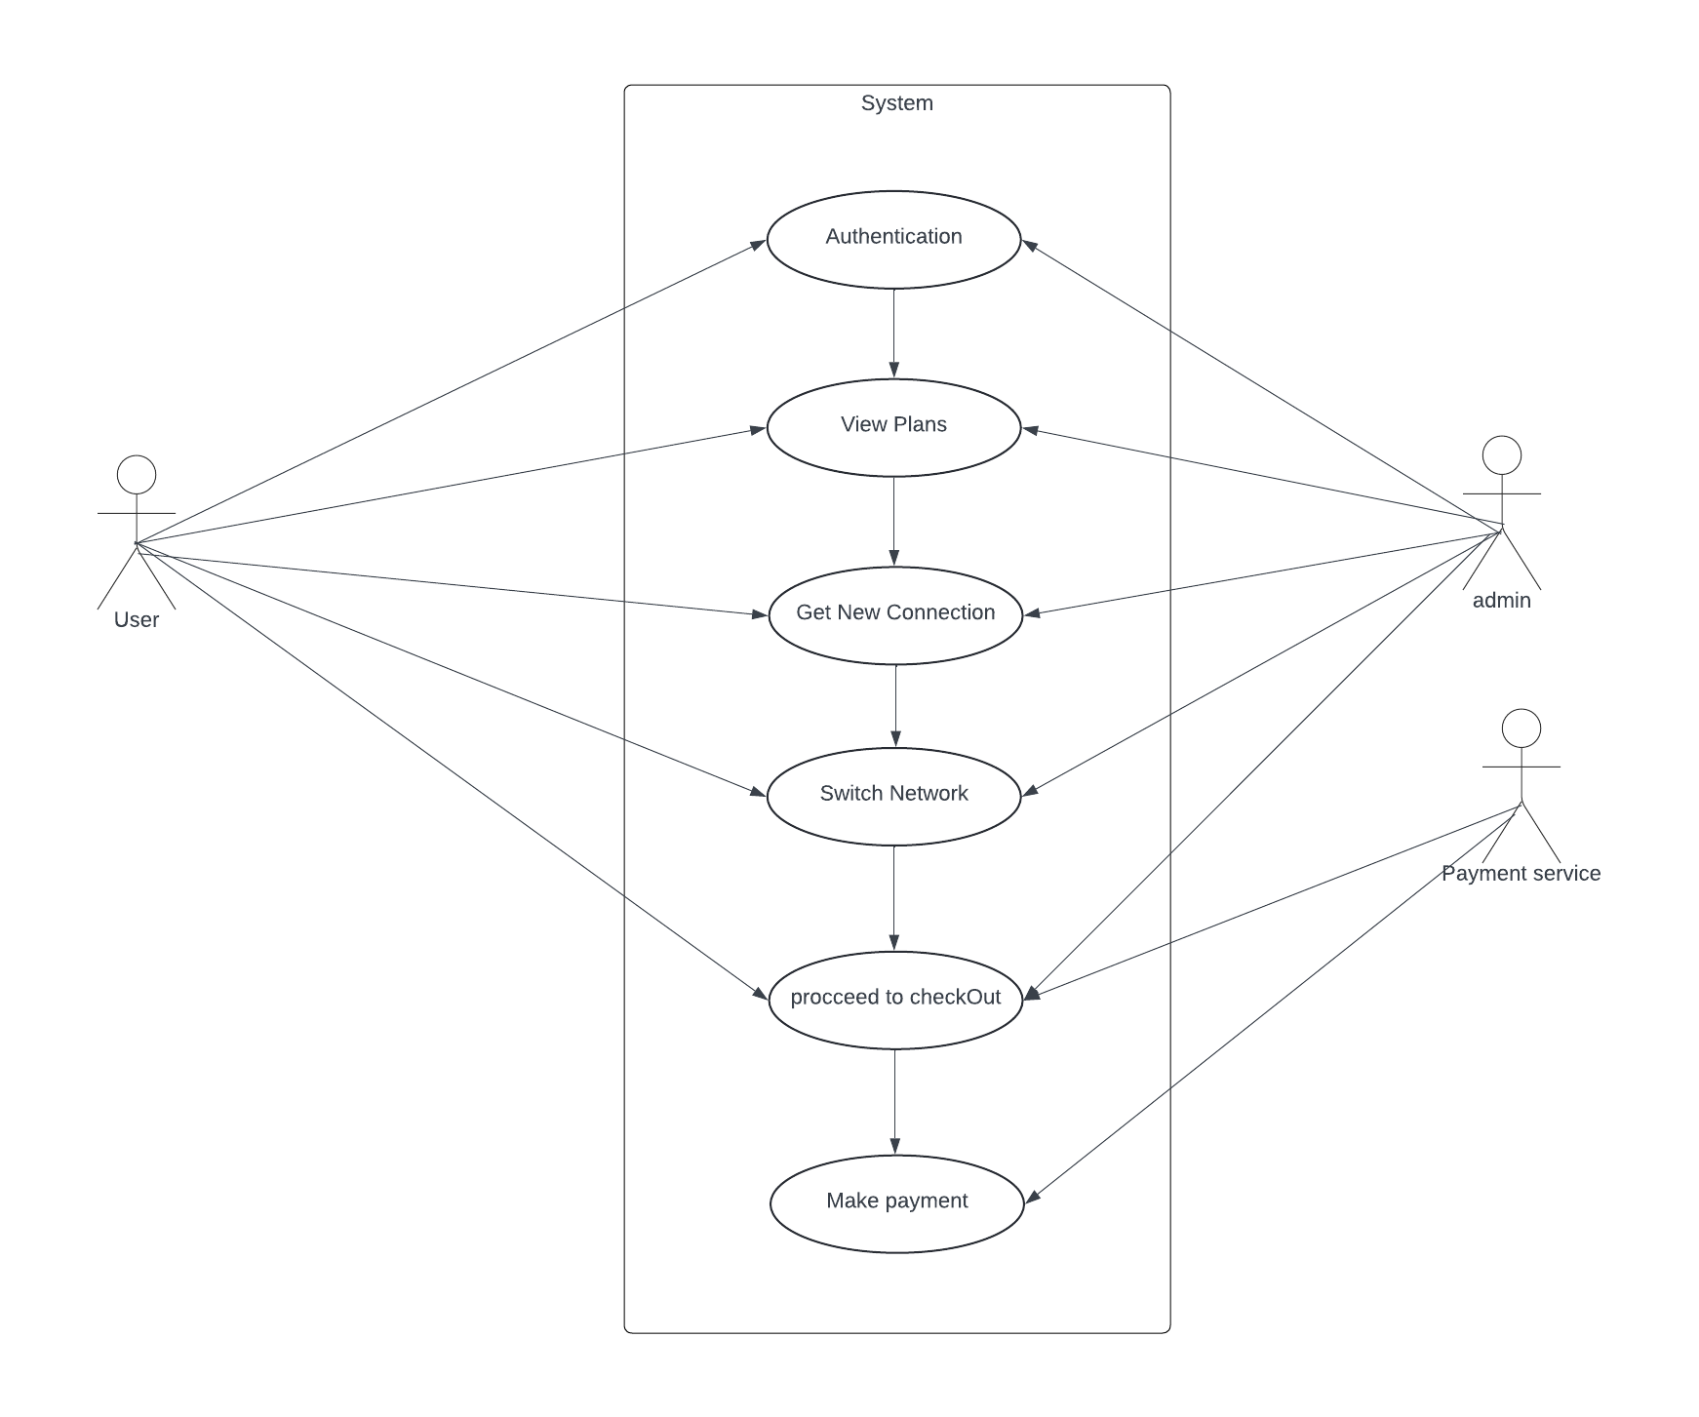

**Class Diagram**

Class diagrams are the blueprints of your system or subsystem. You can use class diagrams to model the objects that make up the system, to display the relationships between the objects, and to describe what those objects do and the services that they provide. Class diagrams are useful in many stages of system design.

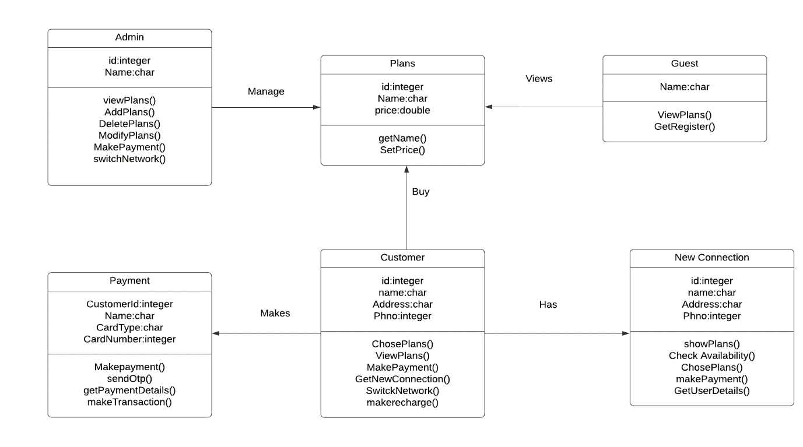

**Sequence Diagram**

A sequence diagram is a Unified Modeling Language (UML) diagram that illustrates the sequence of messages between objects in an interaction. A sequence diagram consists of a group of objects that are represented by lifelines, and the messages that they exchange over time during the interaction.

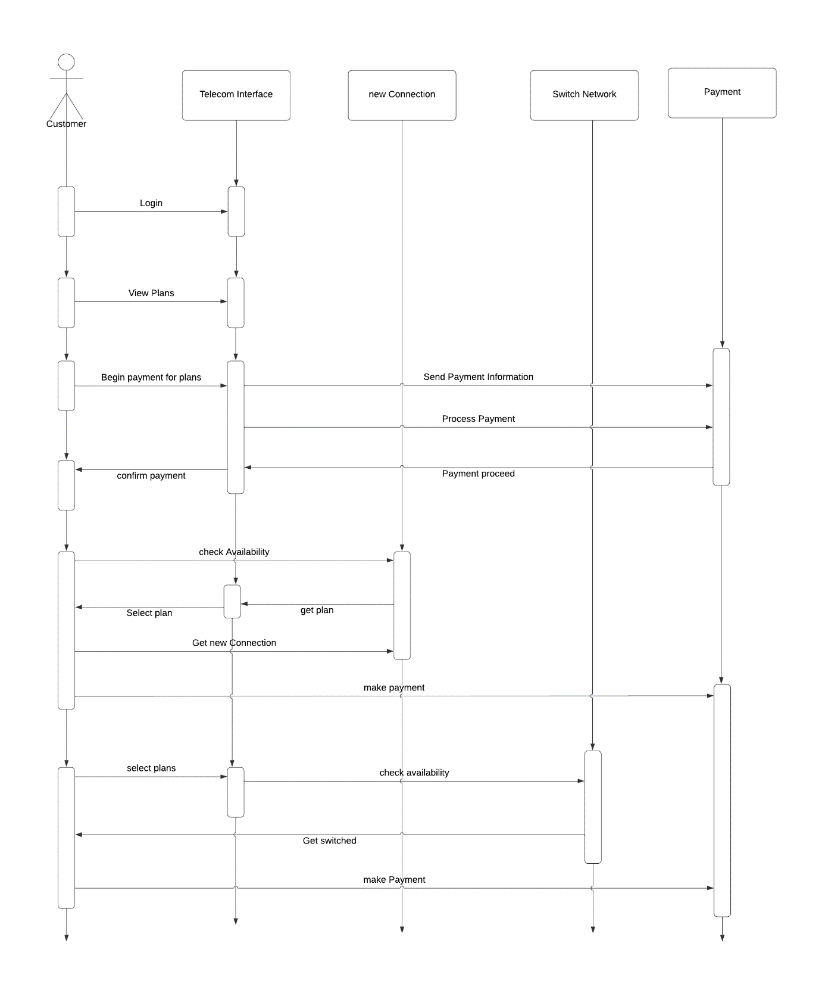

**Conclusion**

The Software Requirements Specification (SRS) for an online Telecommunication system serves as a comprehensive document outlining the functional and non-functional requirements, as well as the overall design and scope of the system.